***LAB ASSIGNMENT 4***

***VANSH BHARDWAJ***

***E22CSEU0519***

1. **There are several methods used to simplify Boolean equations, including:**

1. **Boolean algebra-In Boolean algebra, you use mathematical operations to simplify Boolean expressions. The basic operations are AND, OR, and NOT. You can use laws of Boolean algebra to manipulate expressions, such as the distributive law, associative law, and commutative law.**

1. **Karnaugh maps-Karnaugh maps are a graphical method of simplifying Boolean expressions. They are also known as K-maps. K-maps are a table where each row and column correspond to a combination of input values. The cells in the table represent the output values. You can group adjacent cells with a value of 1 to create simplified Boolean expressions.**
2. **Quine-McCluskey method- The Quine-McCluskey method is an algorithm for finding the prime implicants of a Boolean function. Prime implicants are the smallest possible Boolean expressions that cover all the minterms of the function.**
3. **Espresso heuristic logic minimizer - Espresso is a software tool that uses a heuristic algorithm to minimize Boolean expressions. It is commonly used in digital design and verification.**
4. **Algebraic manipulation-Algebraic manipulation involves using algebraic rules to simplify Boolean expressions. This method is similar to Boolean algebra, but it uses more advanced techniques.**

**K-Maps for 2, 3, and 4 variables:**

**Here are the K-maps for 2, 3, and 4 variables. The K-maps show the min-terms for each variable combination.**

**K-map for 2 variables:**

|  |  |  |
| --- | --- | --- |
|  | **0** | **1** |
| **0** | **m0** | **m1** |
| **1** | **m2** | **m3** |

**K-map for 3 variables:**

|  |  |  |  |  |
| --- | --- | --- | --- | --- |
|  | **00** | **01** | **11** | **10** |
| **0** | **m0** | **m1** | **m3** | **m2** |
| **1** | **m4** | **m5** | **m7** | **m6** |

**K-map for 4 variables:**

|  |  |  |  |  |
| --- | --- | --- | --- | --- |
|  | **00** | **01** | **11** | **10** |
| **00** | **m0** | **m1** | **m3** | **m2** |
| **01** | **m4** | **m5** | **m7** | **m6** |
| **11** | **m12** | **m13** | **m15** | **m14** |
| **10** | **m8** | **m9** | **m11** | **m10** |

2. **Canonical SOP:**

**F= A.B + B.C + C.D**

**= A.B.(C+C’).(D+D’)+(A+A’).B.C.(D+D’)+(A+A’).(B+B’).C.D**

**F = ABCD + ABCD’ + ABC’D + ABC’D’ +ABCD + ABCD’ + A’BCD + A’BCD’ + ABCD + ABC’D’ + A’BCD + A’B’CD**

**F=ABCD+ABCD’+ABC’D+ABC’D’+A’BCD+A’BCD’+AB’CD+A’B’CD**

**3.**

#VANSH BHARDWAJ

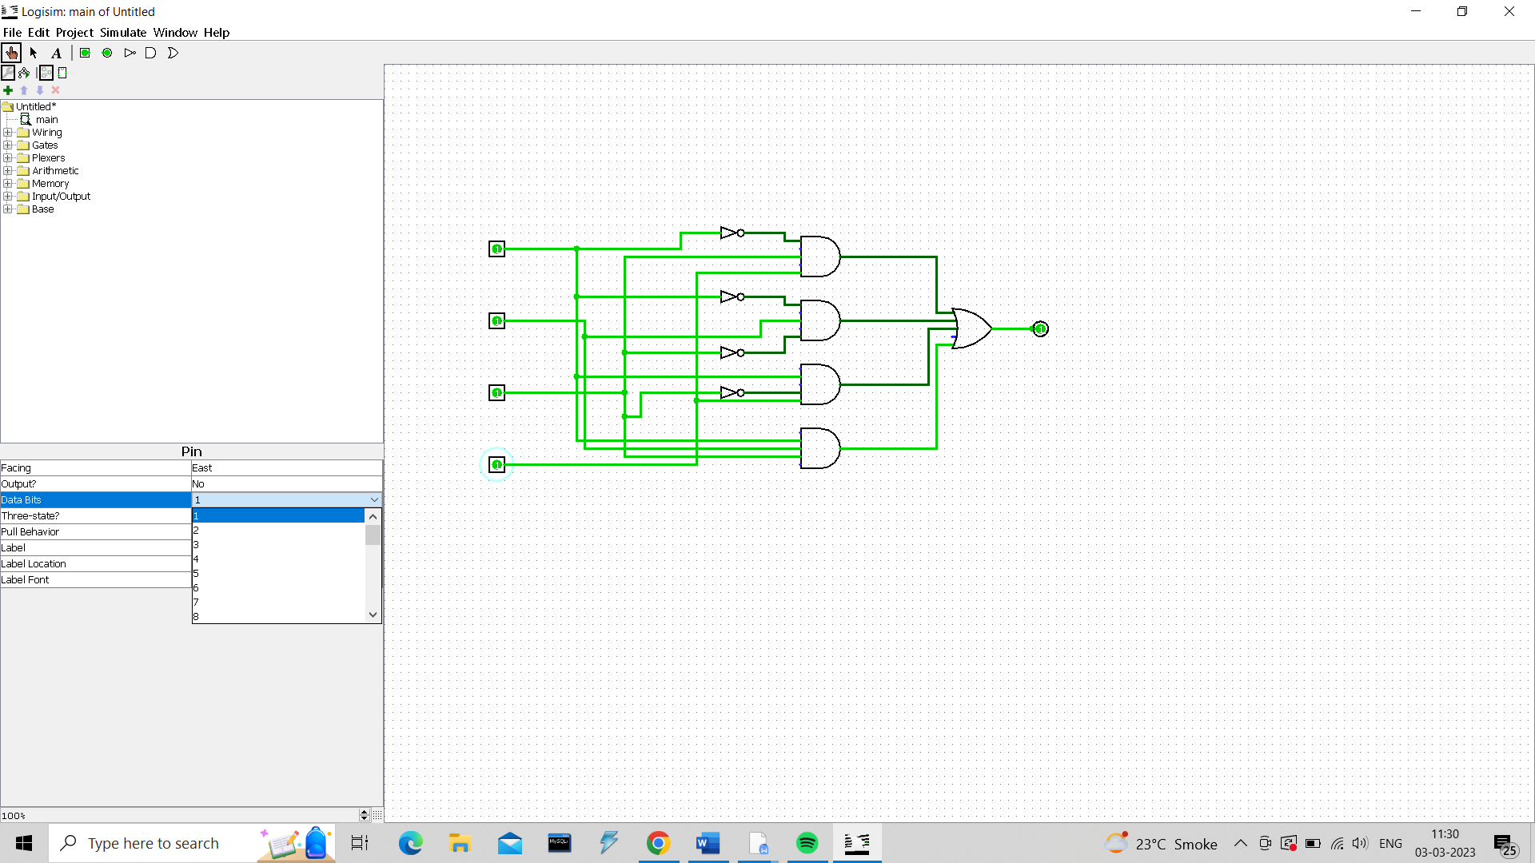

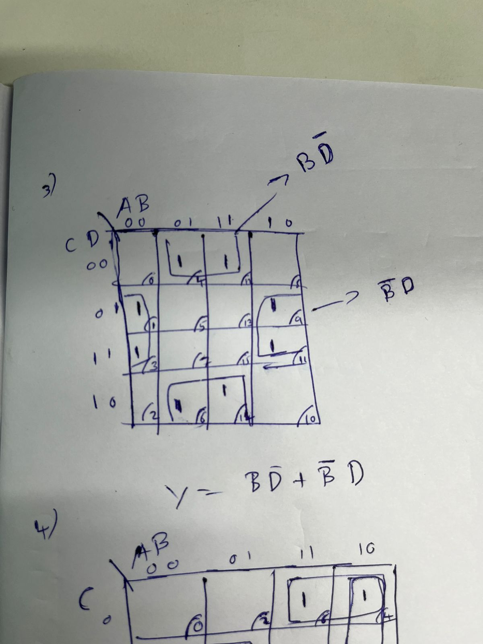

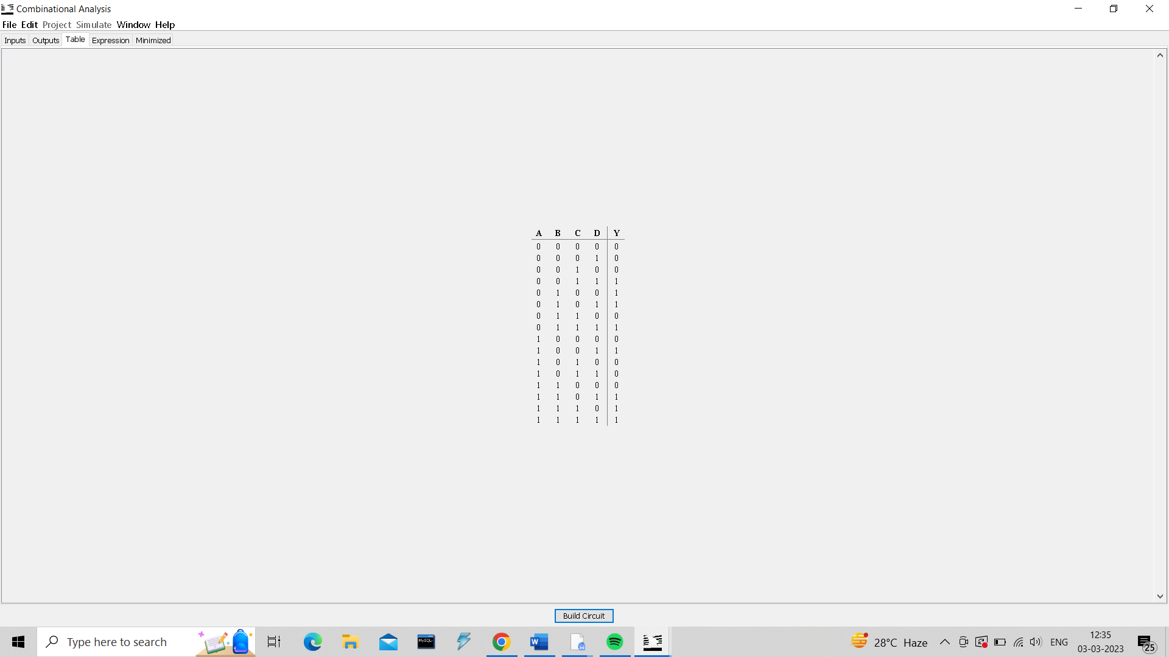

4.

#VANSH BHARDWAJ

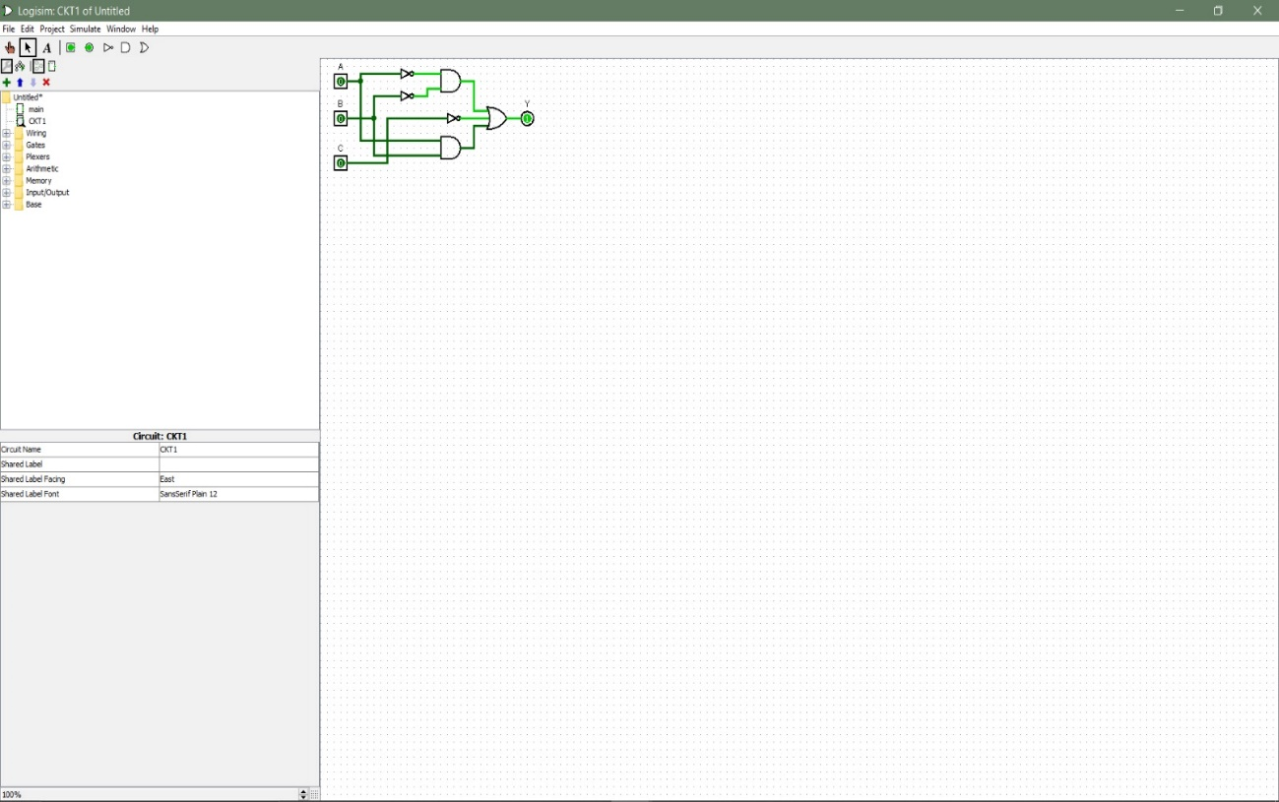

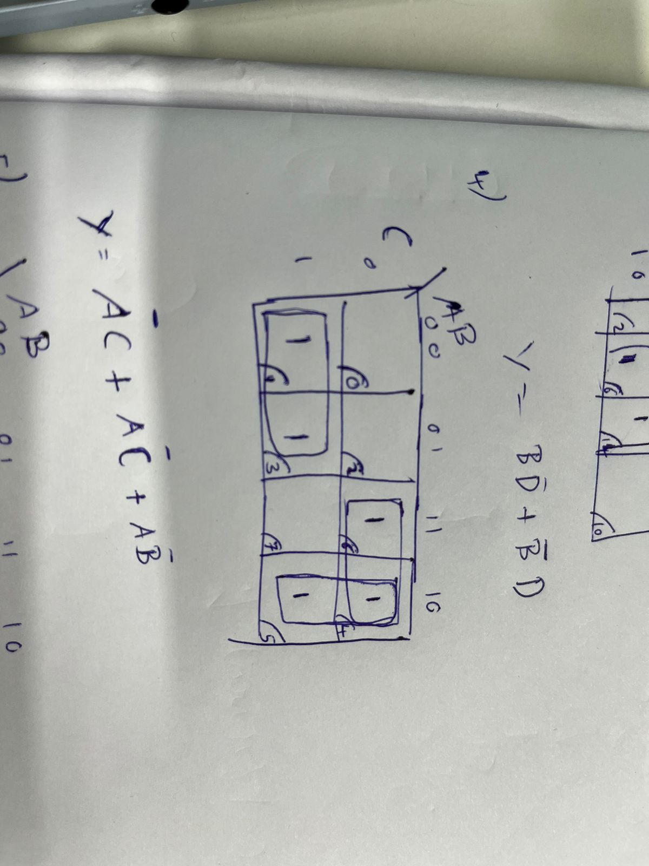

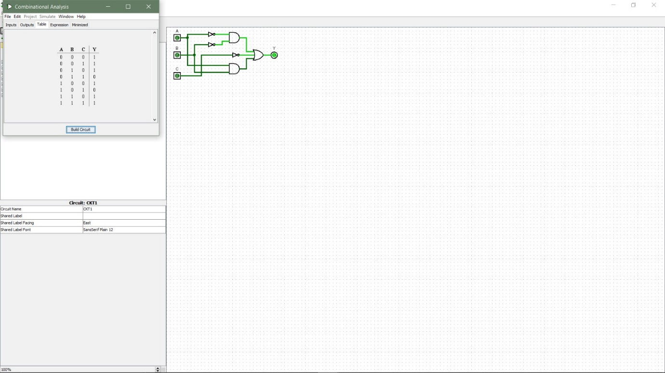

5.

#VANSH BHARDWAJ



